COMMUNITY CONTACT:

Gary Harrop, President
Mazomanie Community Development Corporation 222 W. Commercial Street
Mazomanie, WI 53560
608-795-2120
gharrop@thepeoplescommunitybank.com

Located 40 minutes from Madison, two hours from Milwaukee, and three hours from Chicago, the Mazomanie Business Park consists of 175 acres along US 14 in the Village of Mazomanie. Park tenants include Cardinal Glass, Kroger, Wick Buildings, Electronic Theater Controls, and Plastic Ingenuity. One lot consisting of almost 17 acres is available for immediate purchase. This lot is within a Tax Increment Finance District and is eligible for inclusion in the Dane County Foreign Trade Zone 266. Full details for this site and the supporting infrastructure are provided below.
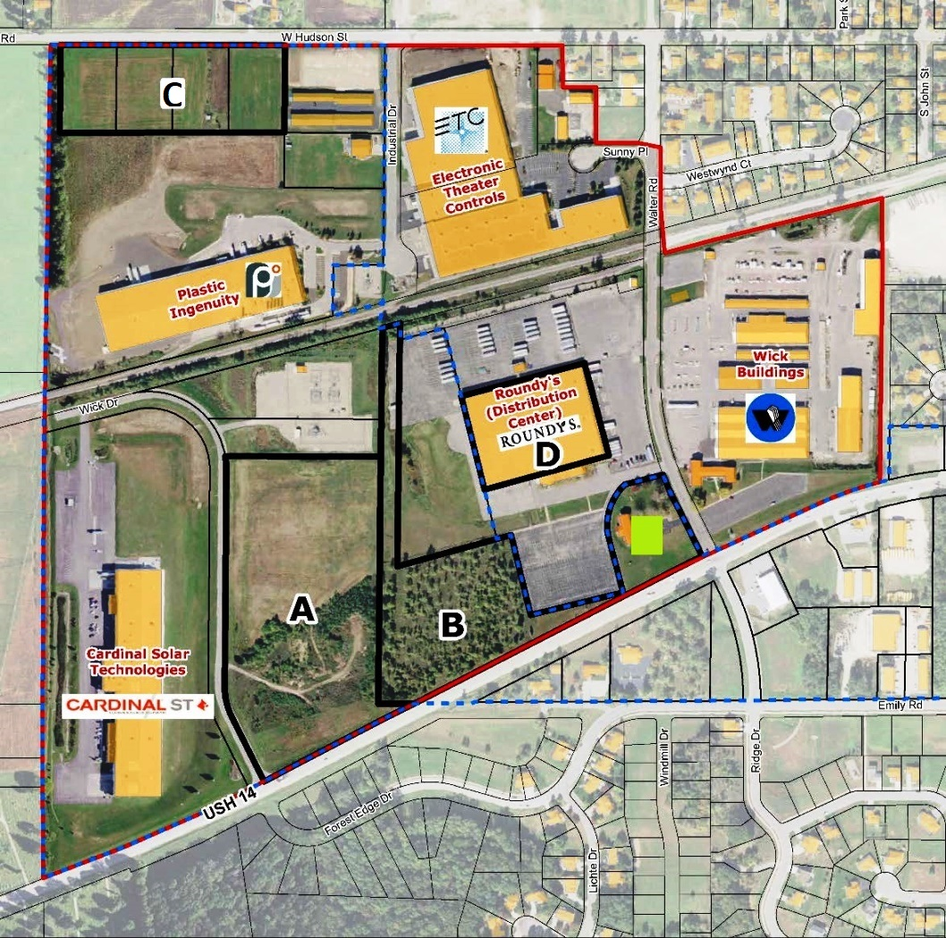

AVAILABLE SITES AND BUILDINGS

 | Site A
Street Address | Hwy 14/Wick Drive
Lot Size (acres) | 16.60
Shape | Rectangle
Dimensions | ~ 625’ x 1,150’
Available Building  Space | Vacant land
For Lease/Sale | Lease or sale
Asking Price | Negotiable
Availability | Immediate
Shovel-Ready | Yes
Tax Increment District | Yes
Present Use | Vacant
Prior Use | N/A
Zoning | I-1, Industrial
Topography | 2-6% slope south to north
Soil Type | Dickinson sandy loam and loamy fine sand (non-hydric)
Floodplain / Wetlands | No
Owner | Village of Mazomanie
Broker | N/A
Contact Name | Gary Harrop
Phone | 608-795-2120
Email | gharrop@thepeoples communitybank.com
Property Listing | N/A

TRANSPORTATION
Primary Access Highway | US 14
Nearest Interstate Highway | ∼25 miles east to Interstate 90/94 via US 14/State Hwy 19
Other Nearby Highways | ∼16 miles south to US 151 via State Hwy 78; ∼10 miles north to US 12 via State Hwy 78
Rail Services | Potential to add short spurs to connect Sites A, B & C to Wisconsin & Southern Railroad
Airport Services | ∼16 miles east to Middleton Municipal Airport (GAF) via US 14; ∼28 miles east to Dane County Regional Airport in Madison (commercial airfield)
Port Access | ∼105 miles east to Port of Milwaukee
Public Transit Provider | N/A

ELECTRICAL

Service Provider (Name/Contact) | Mazomanie Electric 608-795-2100
Electric Power Service | Three phase; 37.3 megawatt capability; capable of expansion to 100 megawatts
Power Generation Source | Alliant Energy
Line Size (kV) | 12.5 kV
Substations Feeding Park | 2
Distance to Closet Sub Station | In Park
Dual Feed Possible | Yes
Distance to Transmission Line | In Park
Transmission Line Size (kV) | 69kV
Rates | http://www.clerkdoc.com/clerkdoc1013/doc/20131014193006760/2016/614.pdf

WATER

Service Provider (Name/Contact) | Village of Mazomanie 608-795-2100
Line Size | 8”-12”
Water Source and Location | 2 local wells
Water Production Capability | 1.036 MGD
Water Storage Capacity | 0.446 million gallons
Average Daily Use/Peak Daily Use | 0.164 MGD/0.397 MGD
Water Additives | Fluoride, chlorine, Aqua Mag (blended phosphate)
Rates | http://www.clerkdoc.com/clerkdoc1013/doc/20131014193006760/2016/614.pdf

WASTEWATER

Service Provider (Name/Contact) | Dane Iowa Wastewater Commission 608-795-0024
Communities Served | Villages of Mazomanie, Black Earth and Arena
Line Size to Lots | 12”
Treatment Plant Design Capacity | 0.693 MGD
Average Daily Use/Peak Daily Use | 0.325 MGD/1.981 MGD
Treatment Process | Activated sludge
Allowable Effluent BOPD Levels | Permitted for 25mg/liter monthly
Rates | http://www.clerkdoc.com/clerkdoc1013/doc/20131014193006760/2016/614.pdf

NATURAL GAS

Service Provider (Name/Contact) | Madison Gas & Electric 608-252-1552
Line Size/Pressure Serving Lots | 6” plastic line/60 psi
Line Size/Pressure Serving Community | 6” steel line; 170 psi

TAXES

Real Property Tax Rate | 2.077% (2015 total of all taxing jurisdictions)
Assessment Value (% of Market value) | 100.00%
Personal Property Tax Rate | 2.077% (2015 total of all taxing jurisdictions)
Tax Increment Finance District | Yes
Foreign Trade Zone | Eligible for inclusion in Dane County Foreign Trade Zone 266; contact David Jensen: 608-246- 3387, jensen.david@msnairport.com
Effective Corporate Income Tax Rate | 7.90% (state only, no local income taxes)
Sales Tax | 5.50% (statewide)

All information contained in this document is deemed reliable but not guaranteed. The Village of Mazomanie does not guarantee accuracy of information. All material information must be independently verified by buyer.

