COMMUNITY CONTACT:

Gary Harrop, President
Mazomanie Community Development Corporation 222 W. Commercial Street
Mazomanie, WI 53560
608-795-2120
gharrop@thepeoplescommunitybank.com

Located 40 minutes from Madison, two hours from Milwaukee, and three hours from Chicago, the Mazomanie Business Park consists of 175 acres along US 14 in the Village of Mazomanie. Park tenants include Cardinal Solar Technologies, Roundy’s, Wick Buildings, Electronic Theater Controls, and Plastic Ingenuity. Two lots totaling 25 acres are available for immediate lease or purchase and another 10,000 sq. ft. of office space is available for immediate lease in a multi- tenant structure. All two lots are within a Tax Increment Finance District and are eligible for inclusion in the Dane County Foreign Trade Zone 266. Full details on each of the available sites and buildings and the supporting infrastructure are provided below.
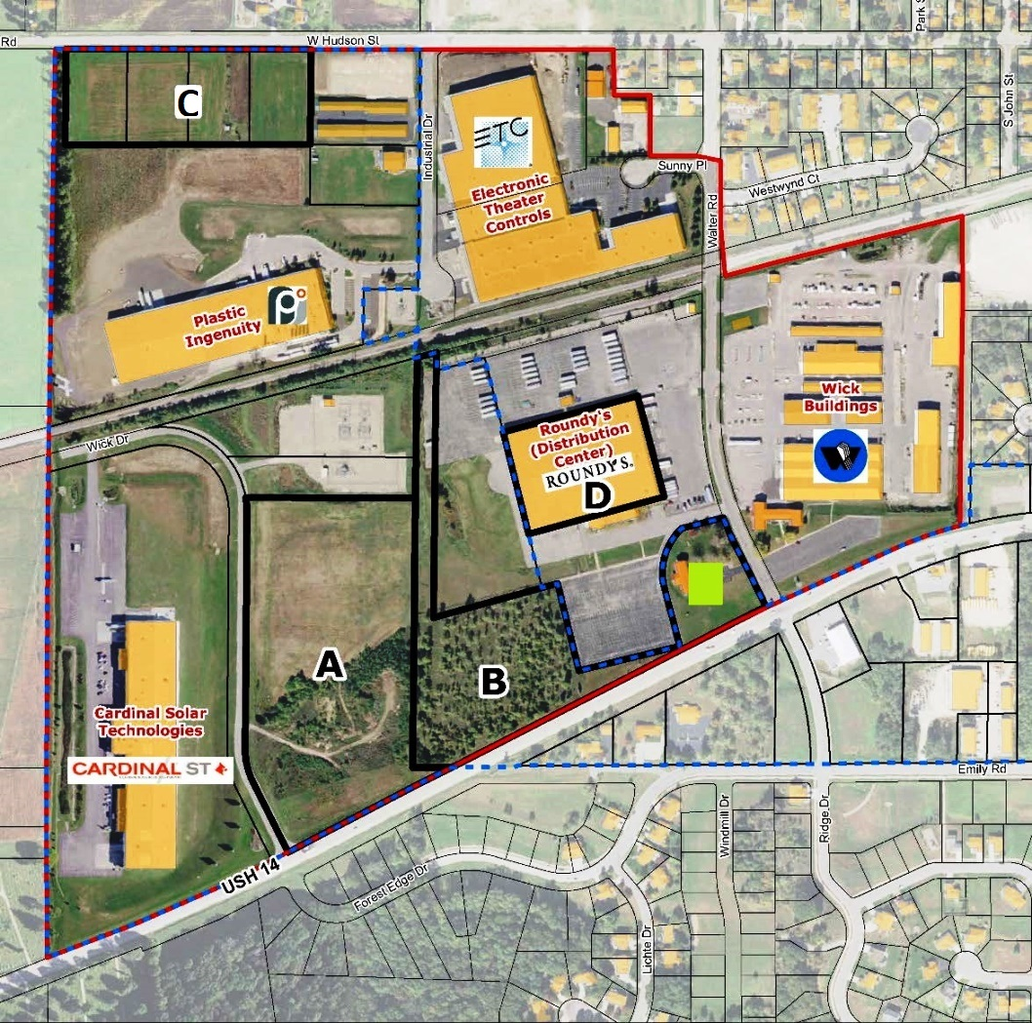

AVAILABLE SITES AND BUILDINGS

 | Site A | Site B | Site D
Street Address | Hwy 14/Wick Drive | Walter Rd. (through Site D) | 400 Walter Rd.
Lot Size (acres) | 16.60 | 9.04 | N/A
Shape | Rectangle | Trapezoid | N/A
Dimensions | ~ 625’ x 1,150’ | ~ 500’ x 650’ | N/A
Available Building  Space | Vacant land | Vacant land | 10,162 sq. ft. office space
For Lease/Sale | Lease or sale | Lease or sale | Lease
Asking Price | Negotiable | Negotiable | $7/sq. ft. (gross lease)
Availability | Immediate | Immediate | Immediate
Shovel-Ready | Yes | Yes | N/A
Tax Increment District | Yes | Yes | No
Present Use | Vacant | Vacant | 10,162 sq. ft. vacant office space; remainder is a  Roundy’s distribution center
Prior Use | N/A | N/A | Office
Zoning | I-1, Industrial | I-1, Industrial | I-1, Industrial
Topography | 2-6% slope south to north | 2-6% slope south to north | N/A
Soil Type | Dickinson sandy loam and loamy fine  sand (non-hydric) | Dickinson sandy loam (non-hydric) | N/A
Floodplain / Wetlands | No | No | No
Owner | Village of Mazomanie | ROS No. 14, LLC | ROS No. 14, LLC
Broker | N/A | Realty Management Consultants | CBRE
Contact Name | Gary Harrop | Greg Butts | Brian Wolff
Phone | 608-795-2120 | 414-281-6000 | 608-663-5445
Email | gharrop@thepeoples communitybank.com | gbutts@rmc-inc.com | Brian.wolff@cbre.com
Property Listing | N/A | N/A | N/A

TRANSPORTATION
Primary Access Highway | US 14
Nearest Interstate Highway | ∼25 miles east to Interstate 90/94 via US 14/State Hwy 19
Other Nearby Highways | ∼16 miles south to US 151 via State Hwy 78; ∼10 miles north to US 12 via State Hwy 78
Rail Services | Potential to add short spurs to connect Sites A, B & C to Wisconsin & Southern Railroad
Airport Services | ∼16 miles east to Middleton Municipal Airport (GAF) via US 14; ∼28 miles east to Dane County Regional Airport in Madison (commercial airfield)
Port Access | ∼105 miles east to Port of Milwaukee
Public Transit Provider | N/A

ELECTRICAL

Service Provider (Name/Contact) | Mazomanie Electric/Sue Dietzen: 608-795-2100
Electric Power Service | Three phase; 37.3 megawatt capability; capable of expansion to 100 megawatts
Power Generation Source | Alliant Energy
Line Size (kV) | 12.5 kV
Substations Feeding Park | 2
Distance to Closet Sub Station | In Park
Dual Feed Possible | Yes
Distance to Transmission Line | In Park
Transmission Line Size (kV) | 69kV
Rates | http://www.clerkdoc.com/clerkdoc1013/doc/20131014193006760/2016/614.pdf

WATER

Service Provider (Name/Contact) | Village of Mazomanie/Sue Dietzen: 608-795-2100
Line Size | 8”-12”
Water Source and Location | 2 local wells
Water Production Capability | 1.036 MGD
Water Storage Capacity | 0.446 million gallons
Average Daily Use/Peak Daily Use | 0.164 MGD/0.397 MGD
Water Additives | Fluoride, chlorine, Aqua Mag (blended phosphate)
Rates | http://www.clerkdoc.com/clerkdoc1013/doc/20131014193006760/2016/614.pdf

WASTEWATER

Service Provider (Name/Contact) | Dane Iowa Wastewater Commission/Brian Sroda: 608-795-0024
Communities Served | Villages of Mazomanie, Black Earth and Arena
Line Size to Lots | 12”
Treatment Plant Design Capacity | 0.693 MGD
Average Daily Use/Peak Daily Use | 0.325 MGD/1.981 MGD
Treatment Process | Activated sludge
Allowable Effluent BOPD Levels | Permitted for 25mg/liter monthly
Rates | http://www.clerkdoc.com/clerkdoc1013/doc/20131014193006760/2016/614.pdf

NATURAL GAS

Service Provider (Name/Contact) | Madison Gas & Electric/Steve Beversdorf: 608-252-1552
Line Size/Pressure Serving Lots | 6” plastic line/60 psi
Line Size/Pressure Serving Community | 6” steel line; 170 psi

TAXES

Real Property Tax Rate | 2.077% (2015 total of all taxing jurisdictions)
Assessment Value (% of Market value) | 100.00%
Personal Property Tax Rate | 2.077% (2015 total of all taxing jurisdictions)
Tax Increment Finance District | Yes
Foreign Trade Zone | Eligible for inclusion in Dane County Foreign Trade Zone 266; contact David Jensen: 608-246- 3387, jensen.david@msnairport.com
Effective Corporate Income Tax Rate | 7.90% (state only, no local income taxes)
Sales Tax | 5.50% (statewide)

All information contained in this document is deemed reliable but not guaranteed. The Village of Mazomanie does not guarantee accuracy of information. All material information must be independently verified by buyer.

